**Bee Diversity in Lowland Puget Sound Marginal Lands**

Evan Sugden1, Will Peterman2, Riley M. Anderson3, Robert Redmond4, David W. Crowder3

1Entomo-Logic, Salt Lake City, UT [evan@entomologic.com](mailto:evan@entomologic.com), 2Bee Search, Seattle, WA [will@beesearch.](mailto:will@beasearch.com)org, 3Washington State University, Pullman, WA [riley.m.anderson@wsu.edu](mailto:riley.m.anderson@wsu.edu), 4 The Common Acre, (deceased)

ABSTRACT

Bee diversity was assessed at 3 marginal, peri-urban sites in the middle Puget Sound over a period of 7 years. A standardized deployment of pan and “blue vane” traps and opportunistic sweep netting were used on a monthly basis, ultimately producing a total of 25,400 specimens from 155 morphogroups from at least 141 species. Chao richness estimation suggests that the overall bee gamma richness could be as high as 182.5, with the greatest contributions from the genera *Andrena* (Andrenidae,) *Osmia* (Megachilidae,) and the “*Evalaeus/Hemihalictus*” complex (Halictidae.) We found <> introduced species, <> County and <> state records and the apparent absence of the threatened *Bombus occidentalis*, despite system trapping in previously known habitat. The data will provide part of a bee diversity baseline for the region.

INTRODUCTION

The bee diversity of western Washington has remained largely undescribed until recently. Bloom et al. conducted an extensive study of bee diversity in the region, considering farm, garden, and parkland habitat (<Boom et al>.) Prior to this, the only major published assessment of bee diversity to date has been Griswold and Tepedino (<1980>) who cataloged bees of the Columbia Basin, ecologically a region very distinct from the maritime Puget Sound zone west of the Cascade Range.

In 2014 The Common Acre, a private non-profit group supporting science and the arts, obtained funding to attempt vegetative restoration of two areas 1) power corridors of the local power utility, Seattle City Light, and 2) a buffer region surrounding the Port of Seattle’s SeaTac Airport. The central purpose of the foundational study, was, therefore, restoration monitoring. It was decided after implementation to measure the success of the restoration effort in part by assessing proximal native bee diversity in a before/after context. A sister site at Boeing Paine Field outside of Everett, WA was added to the restoration and bee monitoring effort in 2018. These sites share habitat characteristics (see Methods) and are distinct from and complimentary to the study areas used in Bloom et al. (2022).

In 2014, TCA engaged the senior author to direct the bee survey work and the second author was soon after employed to join the team. These personnel had recently been involved, as a separate project, in surveying the Puget Sound and some peripheral areas for *Bombus occidentalis*, populations of which have been rapidly declining since about 2000 [do we have a published reference for this?]. The non-profit BeeSearch was founded as a vehicle for the latter work. Upon joining the TCA restoration effort, the authors quickly saw, in addition to addressing restoration monitoring responsibilities, the opportunity to begin a much-needed intensive, long-term, stand-alone bee diversity assessment of the targeted land. The Common Acre initially engaged BeeSearch as a contractor, but the two organizations later functioned under a joint operating agreement with cataloging bee diversity as a goal. In 2017, the vegetation restoration efforts were discontinued and all support was put toward bee monitoring until final data collection in 2020.

The initial focus of the study was to simply document the bee species richness in the study areas. With the addition of the third author for the purpose of deepening our analyses, the study was broadened to include comparison between seasons, between sites, and more sophisticated considerations of richness.

METHODS

Study sites.

Western Washinton; need to start broader, then describe the individual sites.

1. Port of Seattle (POS, SeaTac Airport.) Used 2014-2020. This site is approximately 3 km2 south of the main runways and extending to the southern limit of Port jurisdiction. This land functions as a security buffer zone around the airport. Through the middle of the last century it was largely used as a private golf course, remnant components of which are recognizable, e.g. “sand trap” areas, hardscape around the former clubhouse. We categorize it as “marginal” because of the broad and varied disturbances historically incurred, proximity to intense development, and present state of low- to no management. The vegetation is varied, with a riparian-like zone along a drainage ditch and several plots of attempted past revegetation. The vegetation is mainly “weedy” with notable border hedges of wild Himalayan blackberry, *Rubus befrons*, patches of knapweed, *Centaurea* sp., wild mustard , *Brassica* spp., and edge patches of Big Leaf Maple, Acer macrophyllum. Willow, *Salix* spp. and a mix of tree and shrubs characteristic of Puget Sound lowland wild areas. Open areas with low perennial or annual weedy plants provided the main collecting areas. Trapping stations in this site were separated by at most a few hundred meters. Notably, within 300 m and 1 km of trapping stations were two honey bee (*Apis mellifera*) apiaries with up to 10 functioning hives.
2. Seattle City Light (SCL, power corridor buffer.) Approximatley 10 km SSE of Seattle, King County, WA. Used 2014-2016. This site consisted initially of 4 trap stations located approximately 2 km apart along an E-W transect along the power corridor beginning in the Rainier Beach neighborhood of south Seattle in a semi-managed meadow-like habitat. A second station occupied semi-boggy slope descending toward the Interstate 5 corridor. A third station was formed west of I-5 within the bounds of a weedy SCL equipment storage pad and immediately North of the Duwamish Hill Preserve. A fourth station was established in the Boulevard Park neighborhoos along the banks of the Duwamish River to the northwest of station 3 between a major road and an SCL power transfer station. A fifth station was added in 2016 approximately 100 m to the southeast of station 1 and in essentially identical habitat. In aggregate, “marginal” also describes this complex site for the reasons stated above.
3. Boeing Paine Field (BPF, airport and maintenance facility.) Used 2018-2020. Approximately 10 km SW of Everett, Snohomish County, WA. This site, trapped from 2018-2020, consisted of 5 stations with separations of 50-500 meters. Habitat varied from low-maintenance lawn/meadow to riparian creek/pond, all surrounded by a narrow corridor of red alder (Alnus rubra)-dominated forest beyond which is suburban development and/or airport parking lots and runways. This site is approximately 1 km from the waters of Puget Sound and experiences, compared to the other sites, significant maritime influence. The varied disturbance and non-natural nature of the land again qualifies this site as “marginal.”

<<Descriptive site aspect photos, a few close-ups of primary resources (Figs.)>>

Field Collecting:

Trap stations consisted of uniform linear arrays of 15 6-inch plastic cereal bowls (Solo) placed in 5 clusters of 3 each white, blue, and yellow. These large bowls were replaced in 2016 and subsequently with identically-painted 4 oz. “mini-bowls” with, according to literature ( ) equivalent attractiveness to bees. The yellow and blue paint used was () as used in other bee surveys (). The bowl arrays were accompanied by 3 equally-spaced “blue vane” traps (BanfieldBio, Woodinville, WA) with original fluorescent yellow collecting jars. Thus, we designate this 15+3 configuration as our basic functional trapping unit. A significant variation was employed at BPF, where only a single Blue Vane Trap per 15-bowl array was used. This was a conservation measure in consideration of the potential presence of the threatened Bombus occidentalis, the last know population of which in the Puget sound was within flight range of BPF. <Rough calculations based on number of specimens collected in bowl vs. Blue Vane traps and consideration of such comparisons in the literature ( ) suggests that this variation had approximately 0.6 X the power of the full trap unit.> This was a conservation measure in consideration of the potential presence of the threatened Bombus occidentalis, the last known population of which in the Puget sound was within flight range of BPF. In several of the early years of the survey, traps placed in high vegetation were elevated on wooden stakes with specially designed platforms in an attempt to increase visibility of the bowl. Likewise, in a few instances, Blue Vane traps were suspended from metal rods with a terminal hook. These elevated methods were found not to increase trap catch substantially in our sites, added substantially to deployment effort, were not widely used, and were abandoned in the later years of the study.

Traps were filled with a catch fluid of water containing 5-10 drops of unscented dish detergent. Trap placement was done on a monthly bases from April through September in most years, with collection date sensitive to weather conditions. Trap arrays were placed for a single 24-hour period starting at approximately 8:00-10:00.

Trap collecting was supplemented with net collecting on an opportunistic basis, as described elsewhere (Turley et al. 2024). The method used was most often sweeping with a heavy 15-inch sweep net bag and the standard measurement of effort consisting of 100 sweeps, although this frequently varied according to the extent of substrate.

<Comparative collecting effort between years and between sites, with the main variable being number of trap placement days and the secondary variable proportion of basic trapping unit, supplemented by net collecting, is diagrammed in Table 1.> move to Results.

Specimens were collected from traps by pouring the trap fluid through a fine strainer and then placing directly into pre-prepared and labeled vials filled with 70% ethanol. Trap specimens were segregated by Date/site/station. Net-collected specimens were dispatched with ethyl acetate and then placed in paper and blotter paper “layers” for temporary storage (). Net collected specimens received a number that corresponded to nearest station or stations if in between.

<< THIS SECTION NOT NECESSARY???

Trap function notes

Uniformity of catch

Large vs. small bowls (comparative data?) <Need a literature reference (Droege?) comparing small vs. large bowls or else our own data, analysed, under Results. >

Small bowls used after 2015(?)

Source of bowls

Stands (comparative data?); vs ground placement

Backpack sprayer for bowl filling (Fig., photo)>>

*Lab procedures*

Pickling vs. pinning

Preserving most common, most easily identifiable

Drying of alcohol specimens for pinning <ref. Droege?>.

Data & Specimen filing

Data collection conventions. Dates, combining trap catches, etc. <Combined trap catches for each station, i.e. did not distinguish blue-vane from bowl catch.)

Identification. Process: grouping, high to lower level. Resources at USDA, ARS, PIRC.

Specimen & data repositories.

% in alcohol

location of specimens

*Data Recording & Specimen Processing*

In lab, specimens were removed from alcohol and then grouped taxonomically to the lowest level allowing certainty of identification to species or morphospecies. Data with tentative taxonomic identifications was recorded into a central data base, one record per specimen. Of each included taxon and sex a representative series was then dried in a small tea strainer capsule with a hair drier heat source as described by <Droege et al.> Once so prepared, specimens were then pinned or pointed and set into collection event series. Pre-prepared labels were then applied, including for each specimen a unique project-specific accession number. The number of leftover specimens from each taxon were stored in an archival glass vial which was labeled with the complete collection information. Data entry reflected all pertinent collection information plus putative identification for all specimens. Data was recorded for extra specimens as a separate record with the number of specimens represented. Storage was in standard Schmitt boxes or, once identified, in regulation insect cabinets with preservative.

*Specimen Identification*

Specimens were identified using a variety of resources, including published taxonomic papers, semi-technical guides, on line Discover Life keys, and <>. Professional assistance was sought from a number of specialists by sending them representative samples. We also made a number of personal visits to the USDA Pollinating Insects/Utah State University Bee Collection in Logan, UT to use the extensive collection there and consult directly with resident specialists. Similar help was also sought at the Bohart Museum of Entomology, University of California, Davis, CA. Specimens that eluded species identity were assigned mophospecies numbers that were unique across the collection. Separate numbers were assigned to females and males as correspondence was usually also uncertain.

*Stastistical Analysis*

Riley’s descriptions I will add any data methods once we’ve determined which analyses and figures we’re presenting.

Data & Specimen deposition

Data will be made available to the Washington Bee Atlas project and representative specimens will ultimately reside in the collection of Washington State University. Additionally, all data have been deposited at Dryad (), and all analyses are archived on GitHub ().

RESULTS

Simple findings

Across all sites and the full 7 years of the project we collected a total of <25,441> bee specimens representing <167> species (including male and female morphospecies) from <family data not found> families and <24> currently recognized genera. Alpha richness per site is described below.

Collecting effort by traps and by netting is diagramed in Fig. 1. (I don’t have a way of standardizing collection effort by the number of traps, there is nothing in the data that denotes which individual traps the records came from) Species accumulation overall and per site is graphed in Figure 2, both as raw species counts per year and scaled according to trapping effort (In species accumulation curves, the x-axis is the “collection effort”, in our case, the species accumulation curves use each station/year combination as a “sample”, then a bootstrap resample of those combinations is used to create the curves. In POS, we have more station/years, so more “samples”.). Comparison with Chao richness estimates is discussed below. Specimens and species collected per site by trapping and netting appears in Table 1. Further analysis of net collecting dynamics is discussed below.

Raw species counts across year and site

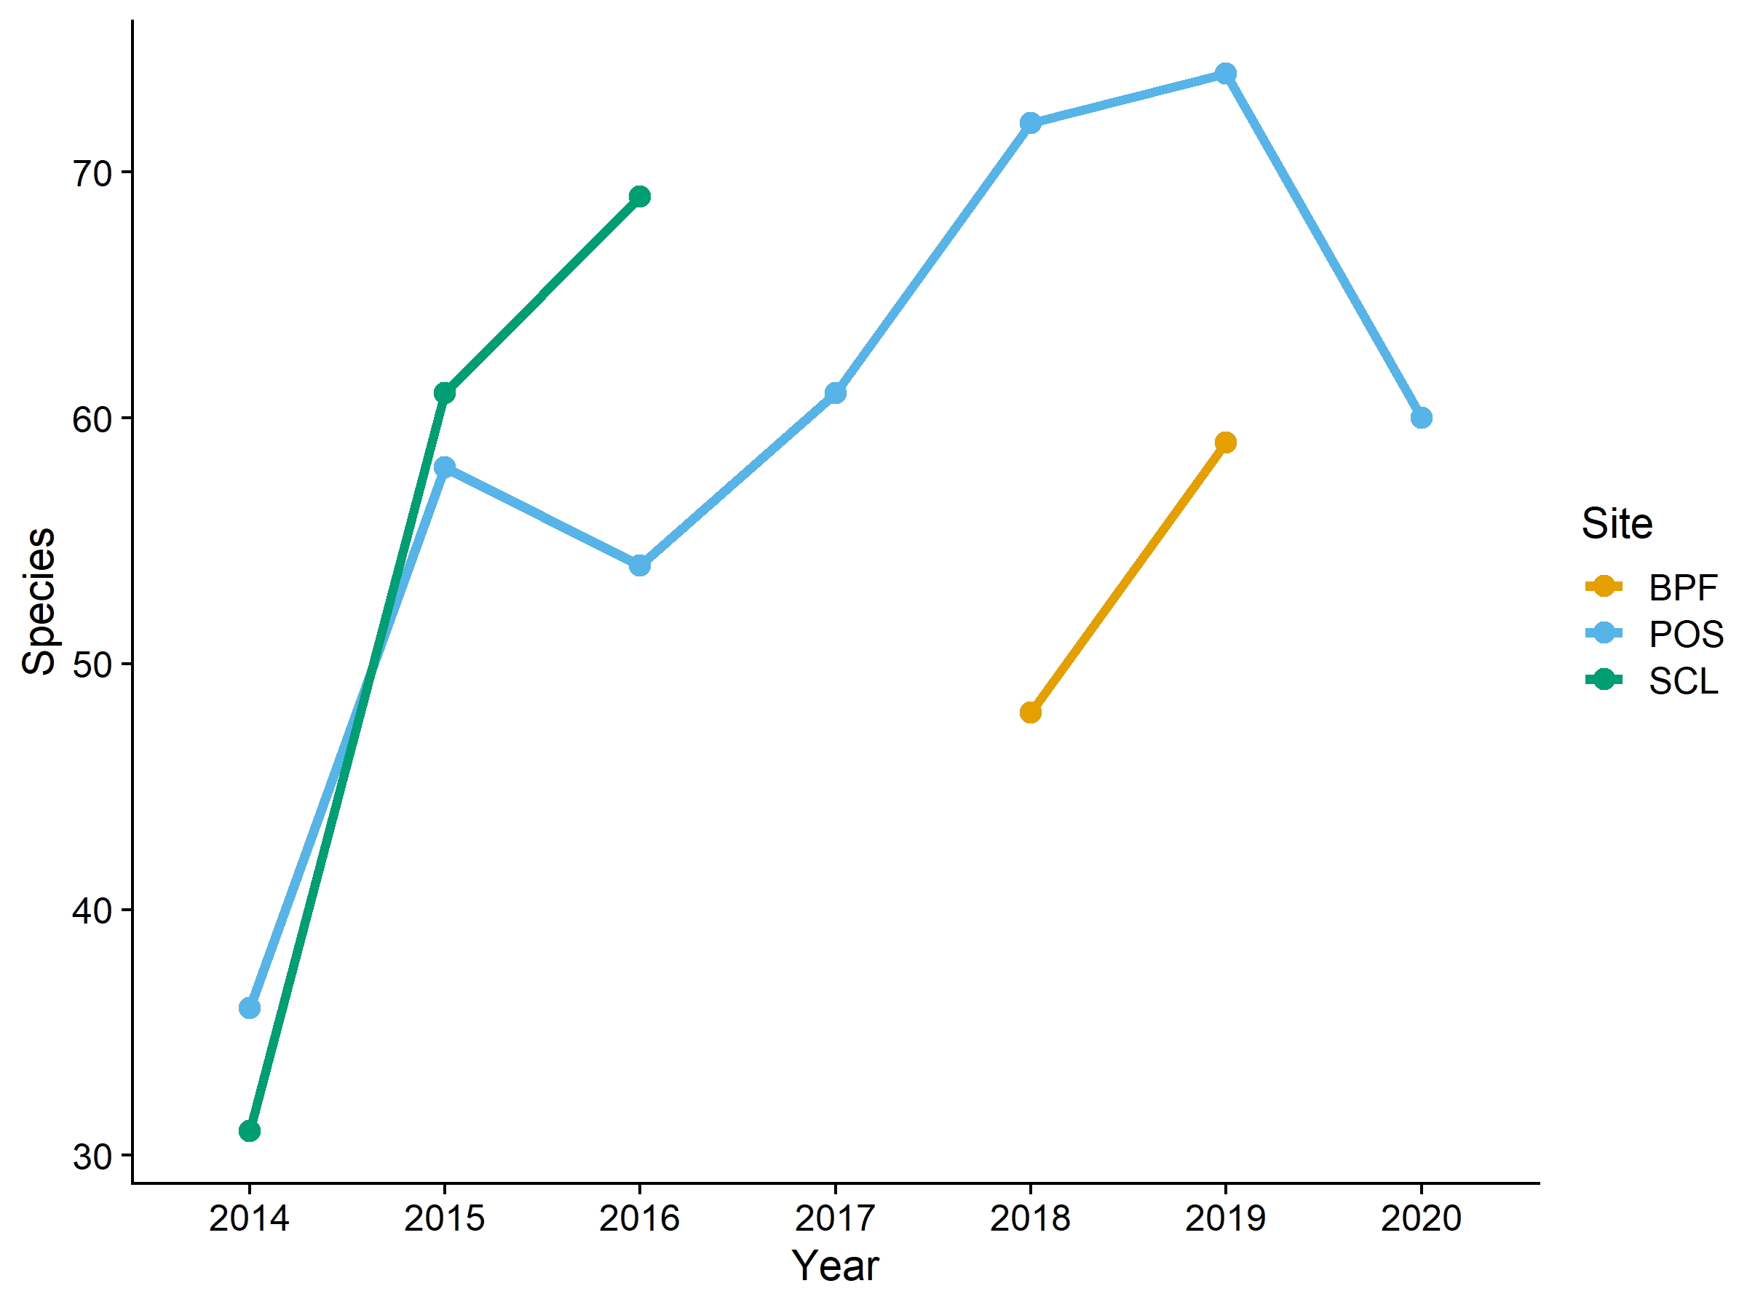

Trimmed species counts across year and site (some morphospecies excluded)

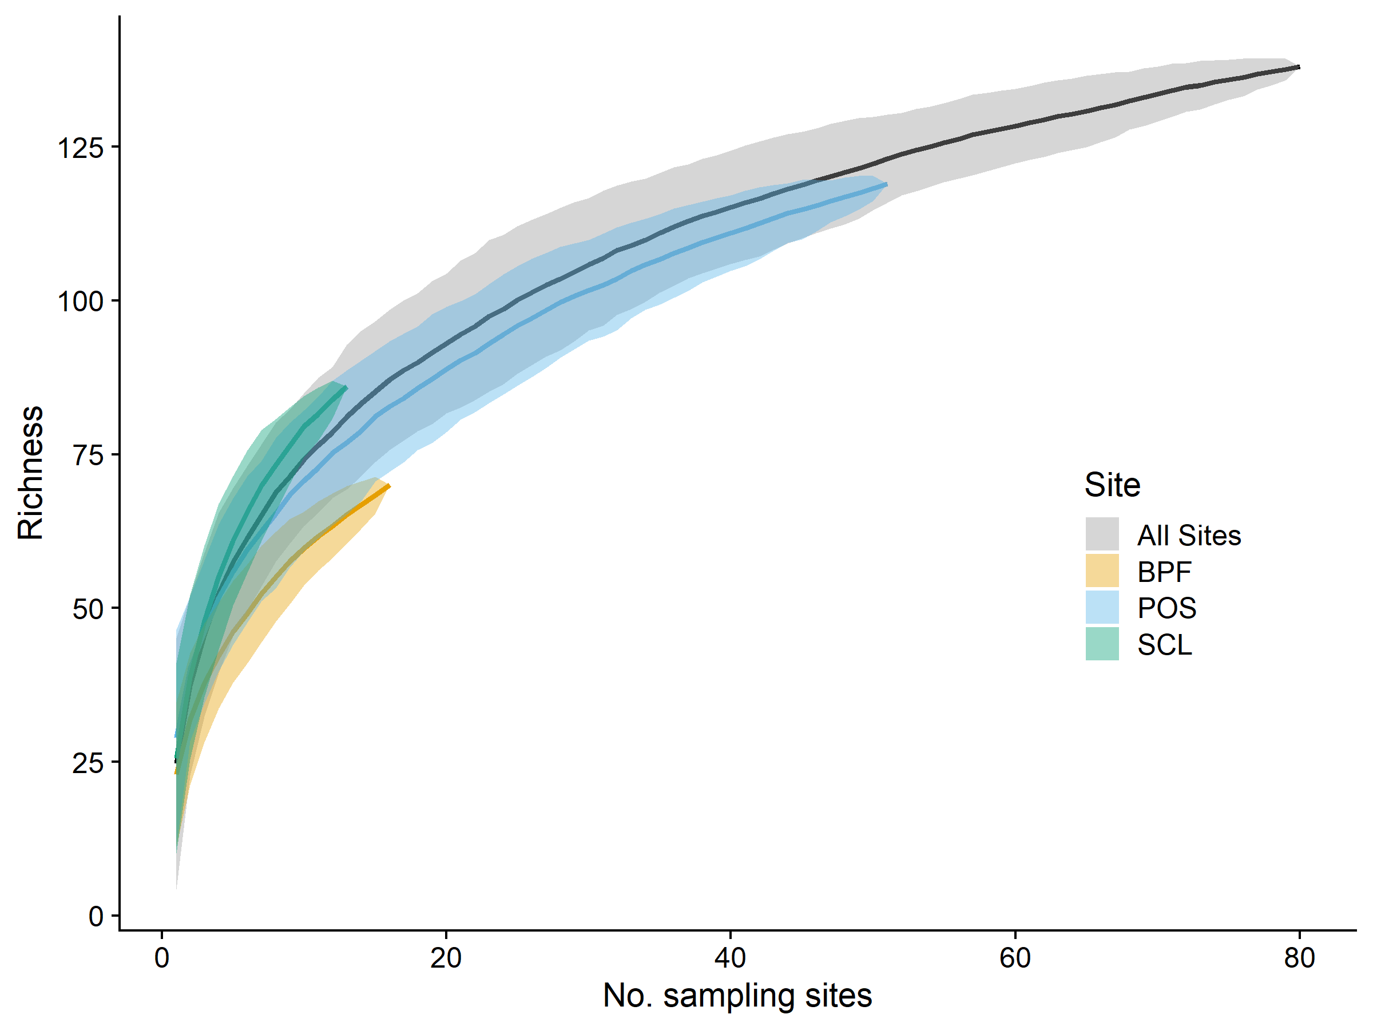

**Species accumulation curves** for all sites (grey), Boeing Plane Field (yellow), Port of Seattle (blue), and Seattle City Lights (green). Collection effort was defined as the number of sampling sites, that is, the number of subsites within each site for each year.

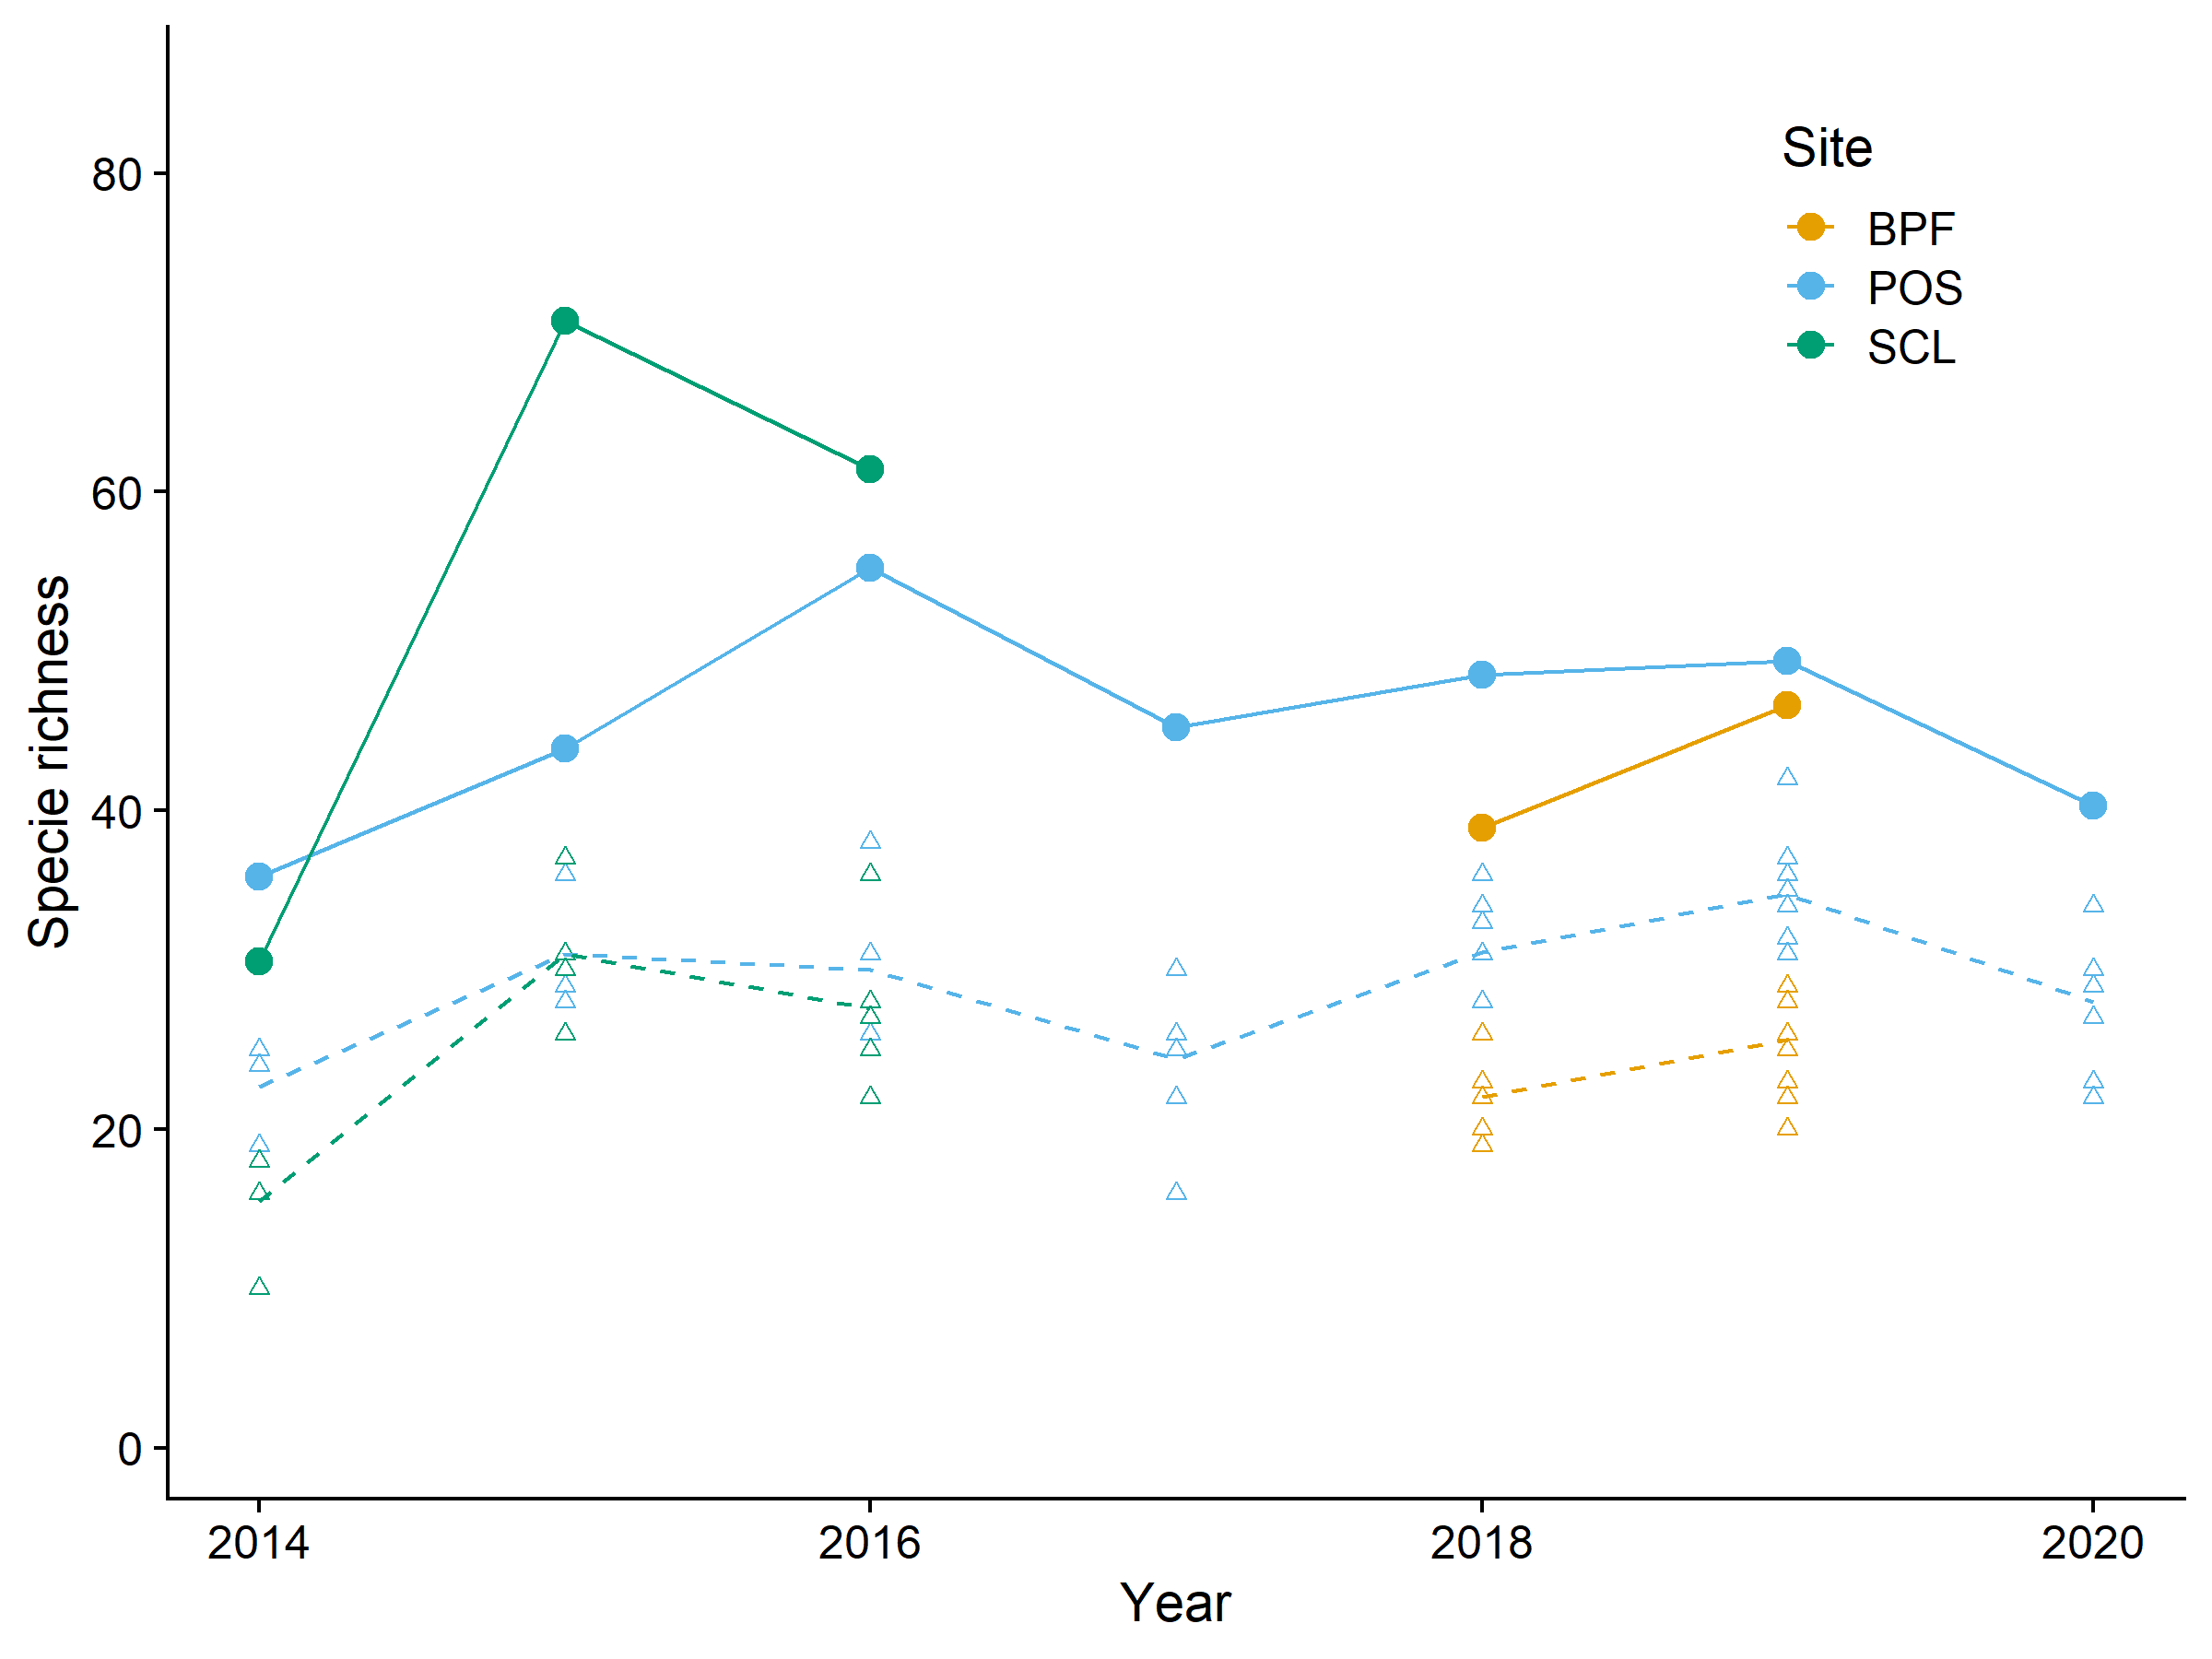**Chao richness estimates.** Points are Chao1 minimum estimated species richness, triangles are raw species counts at each substation within each site. Chao richness estimates are lifted by an additive parameter that accounts for rare species likely missed in the sampling. The data exclude some morphospecies, and all net caught records.

We found <This is not in the data> introduced species accounting for <>% of the overall richness and amounting to <> specimens. These are listed in Table 2. *Also put in Table 3?*

Species which were represented by a single specimen (“singletons”) have a disproportionate influence on some analyses, such as Chao richness and NMDS () and may have special significance regarding collecting technique, conservation, and biogeography (). <> of our recovered species (<> proportion of total richness) were represented by singletons, which are listed in Table 3. In a similar vein, super-abundant species can reflect importantly on community structure and we therefore list in Table 3 the top 10 species by specimen representation. Breadth of distribution can be important in community considerations, so we also list in table 3 those species that were collected in all 3 of our sites. As a comment on collecting technique and the importance of net collecting to supplement traps, we counted <> species that were collected only by net, representing <> of total richness and these are also listed in Table 3, with an indication of those species for which only males were netted and for which at least one female was trap-collected <use an asterisk in the net-collected column>.

Males are often underrepresented in collections for various reasons; we finally list in Table 3 species for which we collected no males by either traps or netting. (I don’t have any of this, but can create it if we want it)

We collected a total of <575> specimens of *Apis mellifera*, representing 2.26 % (575/25441). Of the 575 *A. mellifera* specimens, 213 (37.04 %) were collected by net with the remainder in traps, mostly Blue Vane Traps.

This study did not focus on documenting in detail the differences in trap function regarding bowl vs. Blue Vane or between various bowl colors. Anecdotally, however, we can report that Blue Vane traps excelled in collecting large bodied species and a greater diversity than bowl traps, yet the two trap types were complementary in function.

Analytical findings

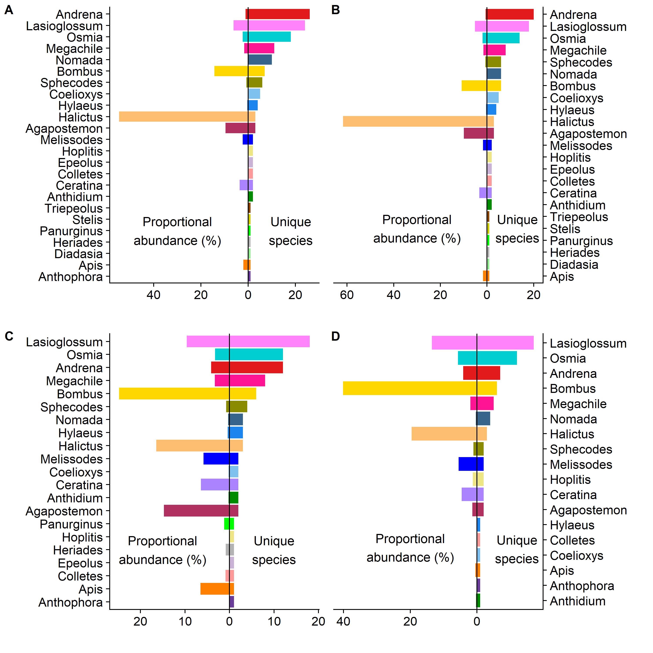

**Proportional abundance and unique species for all 24 genera.** A) All sites collectively, B) POS, C) SCL, and D) BPF.

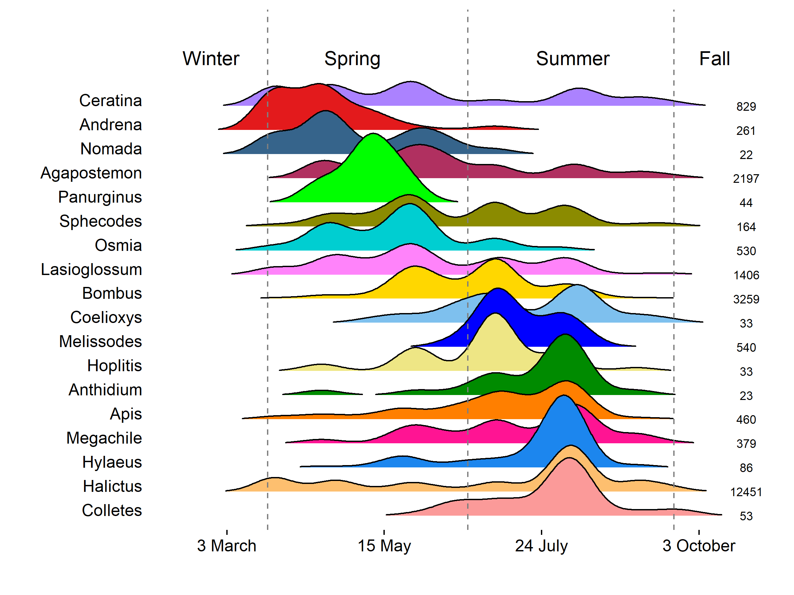

**Distributional abundance of genera across time.** Kernel density estimation with Silverman’s smoothing parameter = 1.27. Data are pooled across sites and years with the total number of records for each genus displayed on the right. The vertical dashed lines represent 21 March, 21 June, and 21 September. Genera are arranged from top to bottom by the mode of their abundance binned at each week, such that early season genera are at the top, while late season genera are at the bottom.

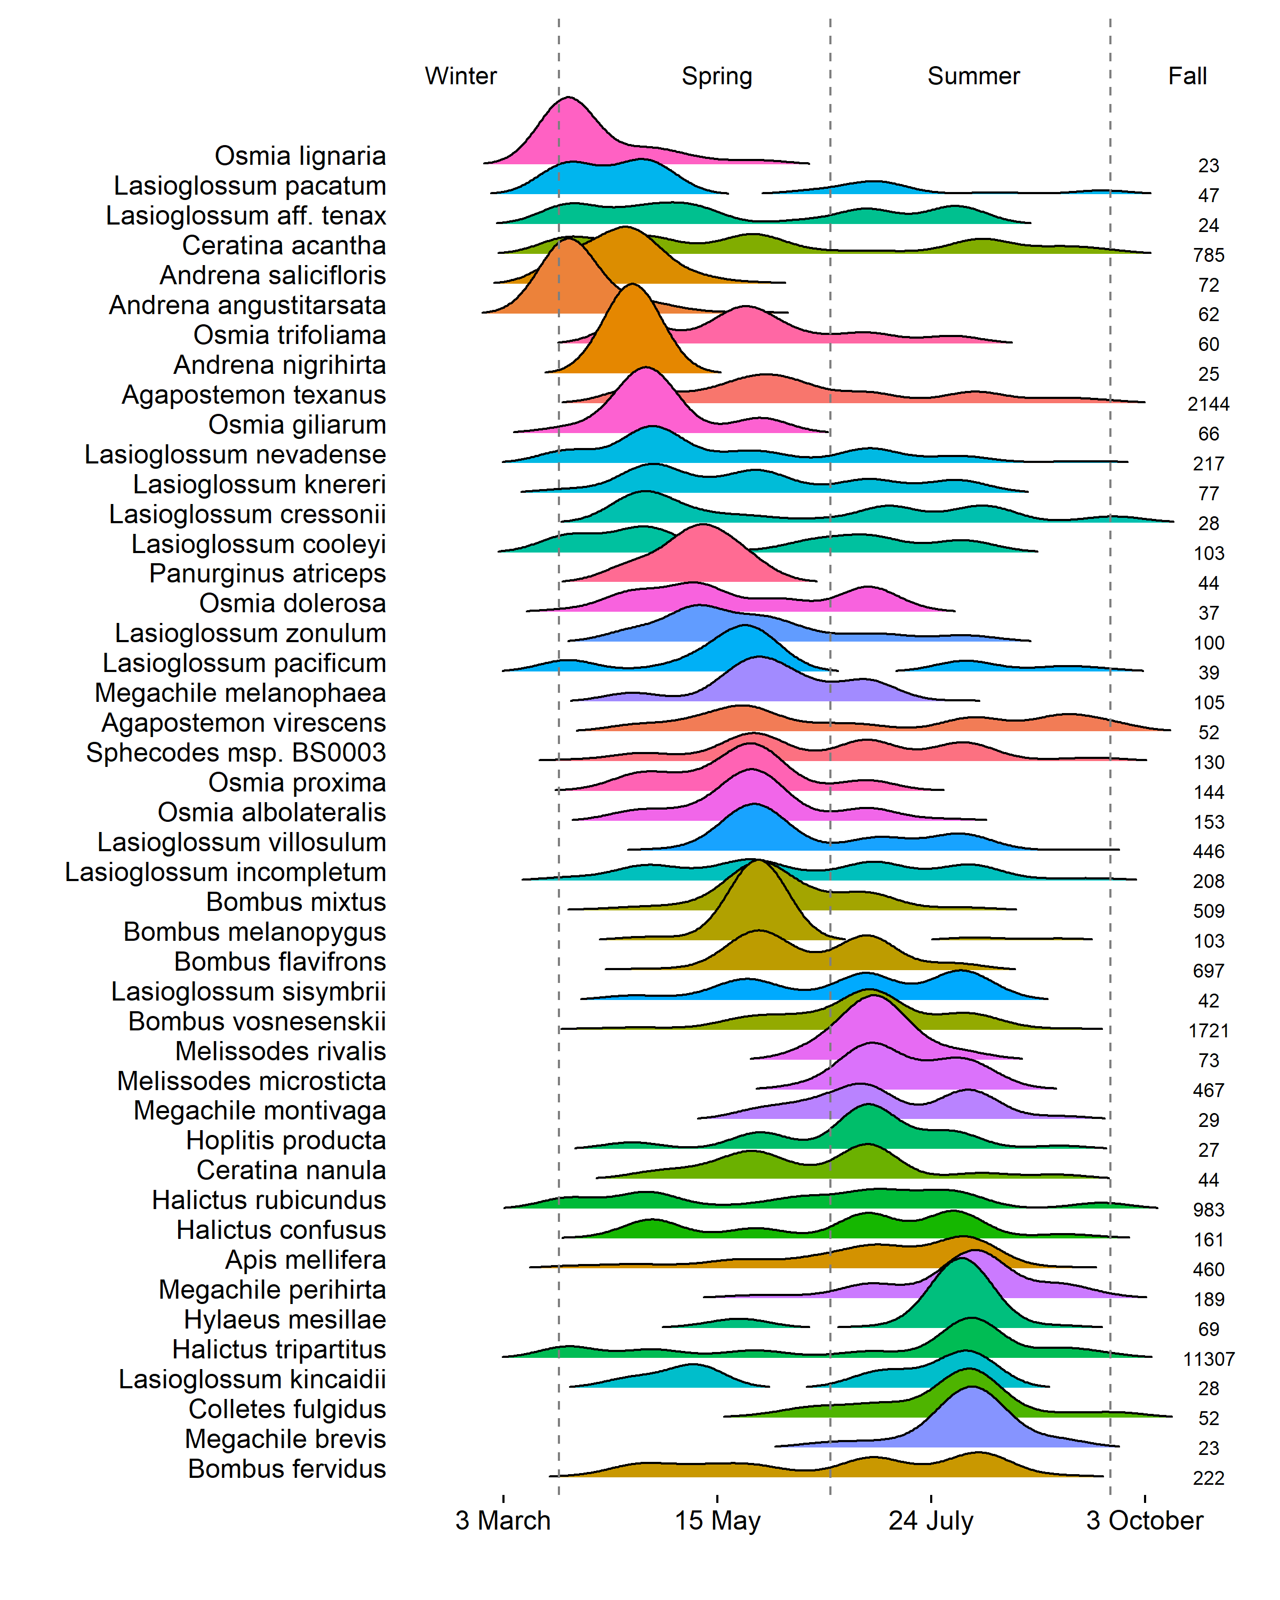

**Distributional abundance of species across time.** Kernel density estimation with Silverman’s smoothing parameter = 1.75. Data are pooled across sites and years with the total number of records for each species displayed on the right. Species with <20 records are excluded. The vertical dashed lines represent 21 March, 21 June, and 21 September. Species are arranged from top to bottom by the mode of their abundance binned at each week, such that early season species are at the top, while late season species are at the bottom.

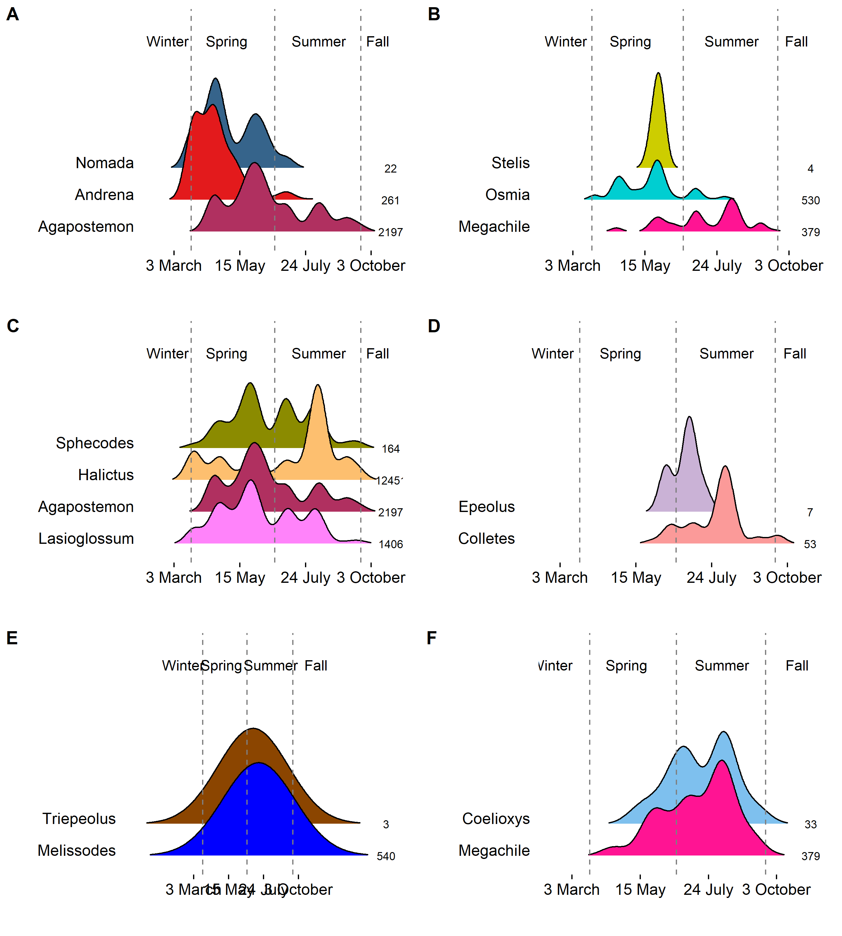

**Distributional abundance of parasite-host species across time.** Kernel density estimation for parasitic genera and their presumed hosts with Silverman’s smoothing parameter for A) Nomada: 1.25, B) Stelis: 0.83, C) Sphecodes: 1.26, D) Epeolus: 0.95, E) Triepeolus: 10.10, and F) Coelioxys: 1.75. Data are pooled across sites and years with the total number of records for each genus displayed on the right. The vertical dashed lines represent 21 March, 21 June, and 21 September.

**Sex ratios of bees by site and collection method.** Points above the dashed line represent male bias, whereas point below represent female bias.

**Variation in community composition across sites.** Bee species are plotted on the first two axes of a three-dimensional non-metric multidimensional scaling ordination of the 69 combinations of station (subsite) and year, across the three sites. Small points are the individual station/year combinations. Large points are the centroids of the three sites. Ellipses are 95% confidence intervals around the site centroids. Bee species shown are the most representative (top 10th percentile of a random forest analysis) of the compositional differences among sites. Text size of the labels is proportional to variable importance score (mean decrease in Gini score).

……………………………………….OLD VERSION…………………………………………..

*Basic results*

Number of specimens overall

Pinned vs alcohol

*Analytical results*

Abundance, Richness, Diversity: Total, by site (Table?)

Accumulation curve: Total, POS (Fig.)

Diversity by family

Spp. accumulation curve (overall)

Estimated diversity overall, by site

Most commonly collected species (10?) by numerosity, date, geography (=most pickled)

Least commonly collected species

Proportion of parasitic species

Non-native/adventive/introduced species

New regional records

DISCUSSION

Overview of results in context of urbanized habitats. Prendergast et al 2022

Approximation of richness, what numbers tell us

family diversity breakdown, Comparision to other studies

Relative diversity between sites (BPF, POS, SCL)

Why so many *H. tripartitus*? Why no males?

The preponderance of *Andrena*, *Osmia*, (“*Evalaeus/Hemihalictus*” complex) comparison to other areas, habitats; mention of recent taxonomic work on latter group.

Usefulness as baseline

Performance of trapping unit

Conservation Implications: habitat complexity, “restoration”, assessment-based strategies

(Comparison of trap performance or lack thereof.)

ACKNOWLEDGEMENTS

For identification service we thank Terry Griswold, Harold Ikerd and Diana Cox-Foster, USDA, ARS, Pollinating Insects Collection, Logan, UT; James Strange, OH State U.; Jason Gibbs, U. Manitoba, Winnipeg, CAN; Joel Gardner, Washington State U. and Robbin Thorp, University of California, Davis (deceased). Kami Koyamatsu assisted in specimen preparation. Chris Looney of Washington State Department of Agriculture provided practical advice. Field site access and support was provided by Seattle City Light, The Port of Seattle, and Boeing Corp. Major funding was provided by the Bullitt Foundation. Allison Rinard, Nat Mengist and Talia London of the Common Acre provided administrative support.

The surviving authors would like to recognize our colleague and junior author, Robert Redmond, now deceased, for his creative vision and scientific facilitation, without which this work would not have been possible.

TABLES

Overall species list*

Ten most common species by 3 criteria**

*species, family, date range of collections, sites at which collected, parasite?, non-native?, range record (State, County)

**10 most common: species, overall numbers collected & proportion of males; species, date range by day of month/species; species, sites at which collected; species, stations within sites?

FIGURES

Accumulation curve overall

POS accumulation curve (finer grain, longer scale)

Diversity overlap diagram, 3 sites

Family composition overall (pie diagram)

Family composition by site (pie diagram)

SUPPLEMENTAL FIGURES

photograph of typical trap placement*

photograph of stand*

photograph of backpack sprayer*

LITERATURE CITED

19<80> Griswold, T. and V. Tepedino. <Bees of the Columbia Basin>

Prendergast et al 2022 A global review of determinants of native bee assemblages in urbanised landscapes

LITERATURE TO OBTAIN

Pan Trap Color Leong JM, Thorp RW (1999) Colour-coded sampling: the pan

trap colour preferences of oligolectic and nonoligolectic

bees associated with a vernal pool plant. Ecol Entomol

24:329–335

Pan Trap Color Toler TR, Evans EW, Tepedino VJ (2005) Pan-trapping for bees

(Hymenoptera: Apiformes) in Utah’s Desert: the importance

of color diversity. Pan-Pacific Entomologist 81:103–

113

Pan Trapping Pollinators Aizen MA, Feinsinger P (1994) Habitat fragmentation, native

insect pollinators, and feral honey bees Argentine ‘Chaco

Serrano’. Ecol Applications 4:378–392

Pan Trapping Pollinators Droege (et al) pan trapping bees

Importance of Rare Species Williams NM, Minckley RL, Silveira FA (2001) Variation in

native bee faunas and its implications for detecting

community changes. Conserv Biol 5:U57–U86

Importance of Rare Species Potts SG, Vulliamy B, Dafni A, et al (2003) Linking bees andflower: how do floral communities structure pollinator communities? Ecology 84:2628–2642

Bee Diversity & Disturbance Winfree R, Griswold T, Kremen C (2007) Effect of human disturbanceon bee communities in a forested ecosystem. Conserv Biol 21:

213–223

Solitary Bee Foraging Range Zurbuchen A, Landert L, Klaiber J, Muller A, Hein S, Dorn S (2010)Maximum foraging ranges in solitary bees: only a few individuals

have the capability to cover long foraging distances. Biol Conserv 143:669–676

Importance of weeds to wild bees. Frankie et al 2013 (cited in Prendergast et al 2022)

Importance of weeds to wild bees. Lowenstein et al 2019 (cited in Prendergast et al 2022)

SUPPLEMENT

Photo of WP backpack bowl filler & trap array.